**Haidy Essam Mostafa Elhamady**

**Lab 2**

**1-Create a script that asks for user name then send a greeting to him**

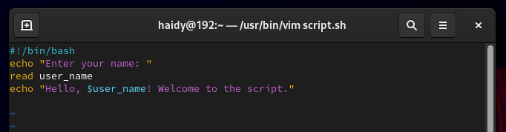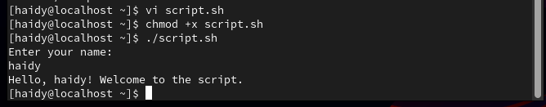

**2-Create a script called s1 that calls another script s2 where:  
a. In s1 there is a variable called x, it's value 5**

**b. Try to print the value of x in s2 by two different ways.**

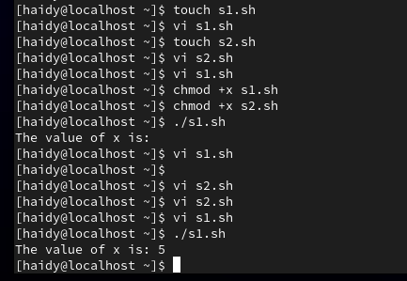

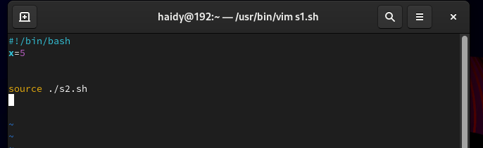

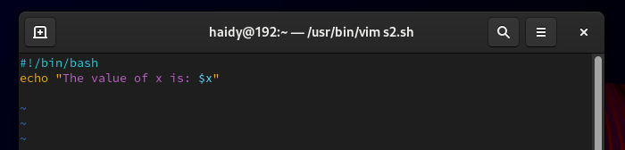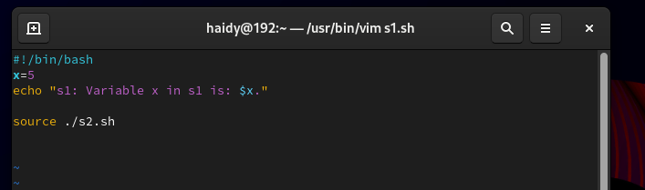

**3. Create a script called mycp where:  
a. It copies a file to another  
b. It copies multiple files to a directory.**

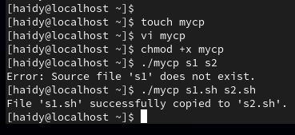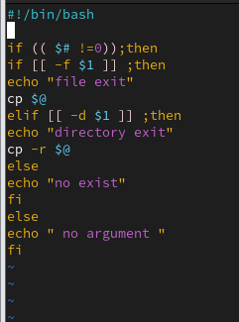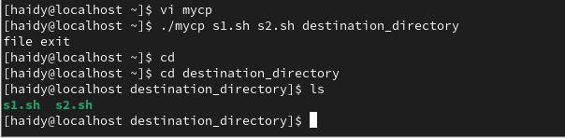

**4. Create a script called mycd where:  
a. It changed directory to the user home directory, if it is called without arguments.  
b. Otherwise, it change directory to the given directory.**

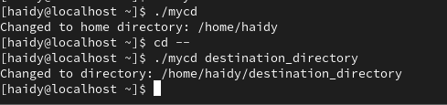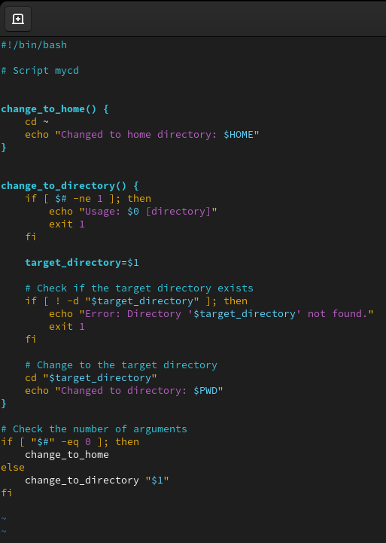

**5. Create a script called myls where:  
a. It lists the current directory, if it is called without arguments.  
b. Otherwise, it lists the given directory.**

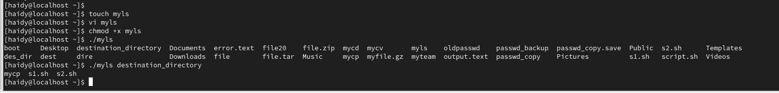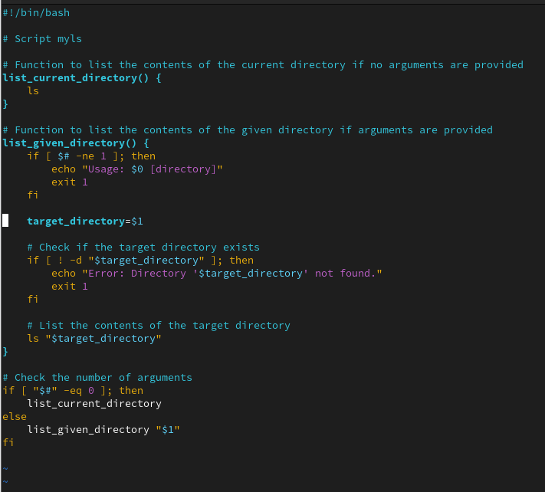

**6. Enhance the above script to support the following options individually:  
a. –l: list in long format  
b. –a: list all entries including the hiding files.  
c. –d: if an argument is a directory, list only its name  
d. –i: print inode number  
e. –R: recursively list subdirectories**

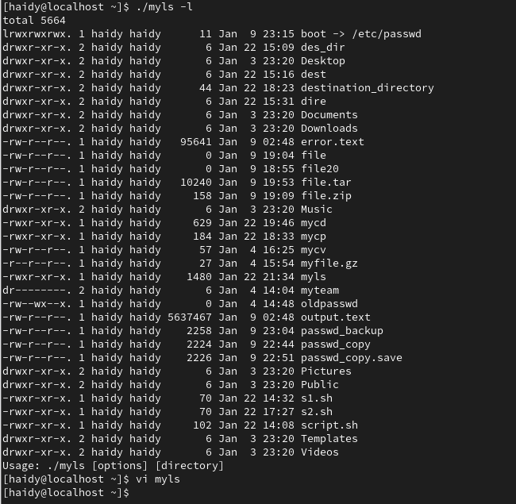

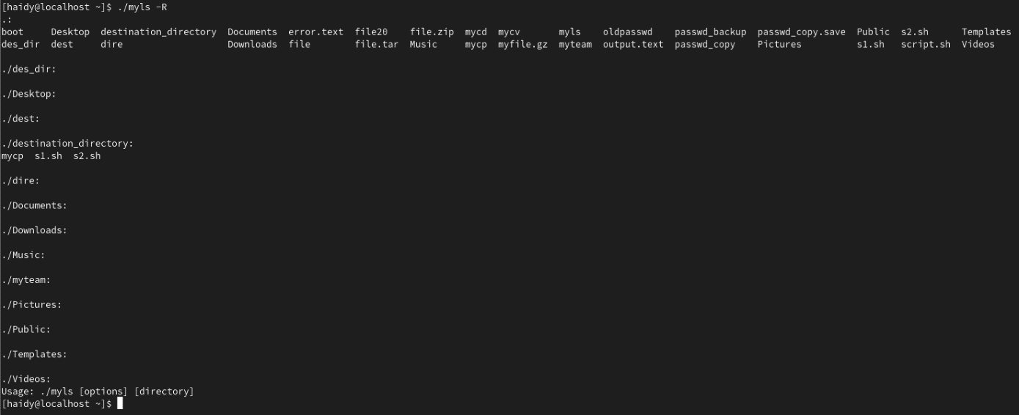

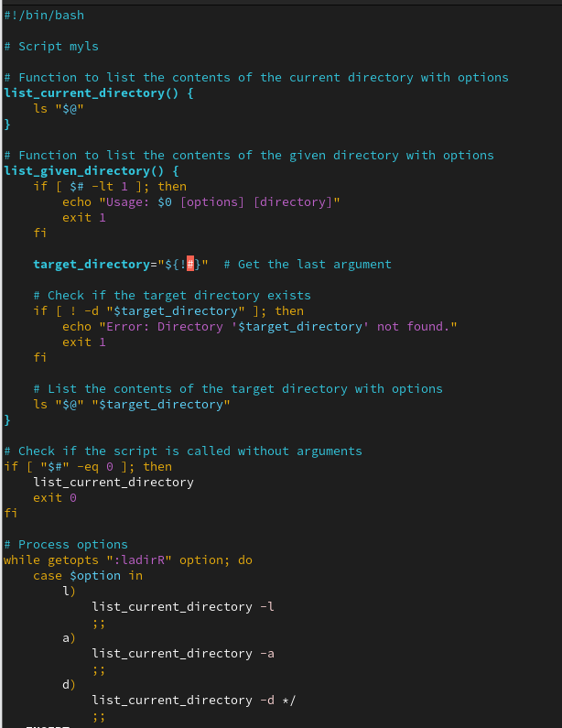

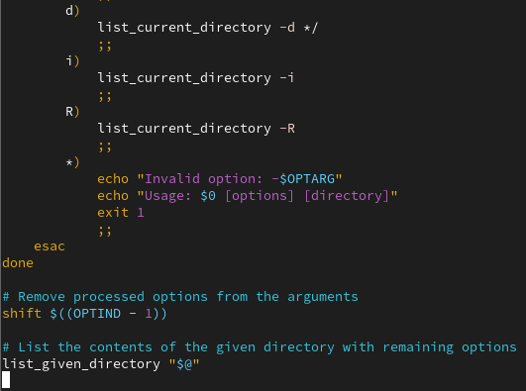

**7. Create a script called mytest where:  
a. It check the type of the given argument (file/directory)  
b. It check the permissions of the given argument (read/write/execute)**

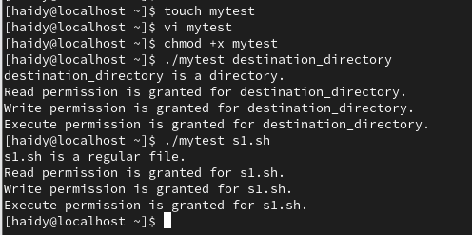

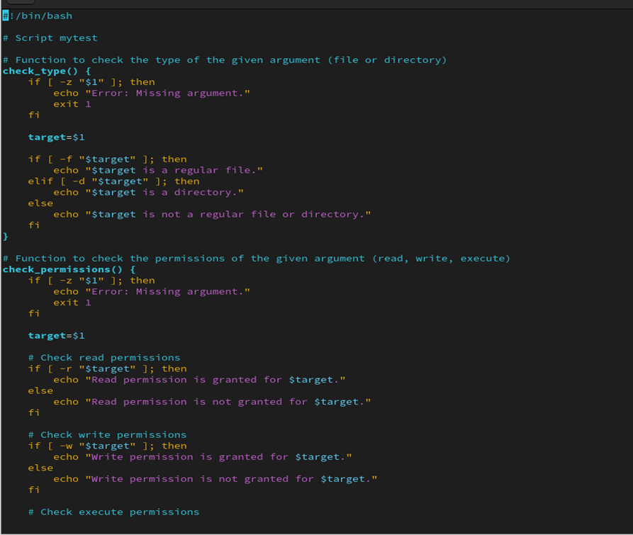

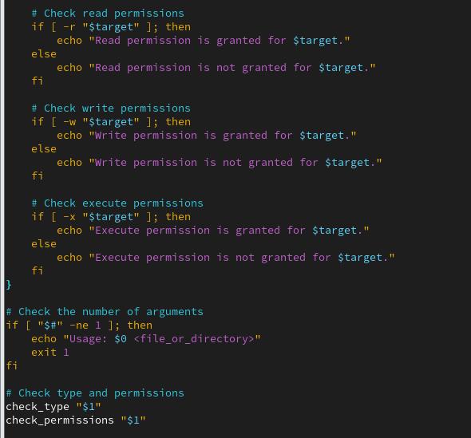

**8. Create a script called myinfo where:  
a. It asks the user about his/her logname.  
b. It print full info about files and directories in his/her home directory  
c. Copy his/her files and directories as much as you can in /tmp directory.  
d. Gets his current processes status.**

